Automation Anywhere

Overview of AA Enterprise

* Easy-to-use, drag-and-drop interface
* Non-invasive to your existing work environment
* Ability to visualize your process as you automate
* Facilitates communication between all systems
* Ensures safety of proprietary information

##### What to Automate?

**AA Enterprise controls a computer through the GUI just like a human user.**

#### **What can be automated?**

* ‘Extracting from’ and ‘inputting to’ all systems - Web – Windows – Cloud – Legacy systems
* Windows and Web user navigation and actions
* Data comparison and validation
* Rule based decisions

#### **What cannot be automated?**

* Hand-written or scanned documents
* Non-rule-based judgment calls

Capabilities of AA Enterprise

AA Enterprise optimizes the time spent on task execution as it:

* **Transforms a repetitive process** to a single mouse click or keystroke.
* **Runs scheduled tasks** anytime by using powerful task scheduling (even when the computer is locked).
* **Automates scripts** that exist in **different formats**.
* **Manages automated processes easily across** single or multiple **machines**.
* **Create** automation **tasks in minutes**.
* **Manage users** with a scalable server that enables easy collaboration.

Capabilities of AA Enterprise

* **Enables centralized systems** for backup, security, and resources.
* **Provides central repository** to capture and reuse automated processes.
* **Easy job scheduling** and batch data processing.
* **Enables automation of FTP/SFTP** processes.
* Allows **download, upload, scheduling and execution of tasks in multi-user environments** (such as Citrix and Terminal Server).
* Provides **MetaBots Designer** to serve unique business needs.

##### Uniqueness of AA Enterprise

* **SMART Automation Technology** that automates complex tasks quickly. - No programming required - Highly reliable and accurate.
* **Centralized Enterprise Control Room** that enables - Easy setup and maintenance of automated processes, users, and client machines.
* **Web and Object Recorder** to recognize objects (even when they change position).
* **Over 550+ actions** available such as Active Directory support, Conditions, loops, and User prompts.

Values of AA Enterprise

**AA Enterprise enables organizations to attain process consistency** by automating and managing workflows, processes, and tasks, such as:

* **Time-consuming data entry processes**
  + Checking inventory
  + Re-ordering supplies
  + Formatting and running reports
* **Website activities** such as logging, searching, submitting web forms, or updating records.

Values of AA Enterprise

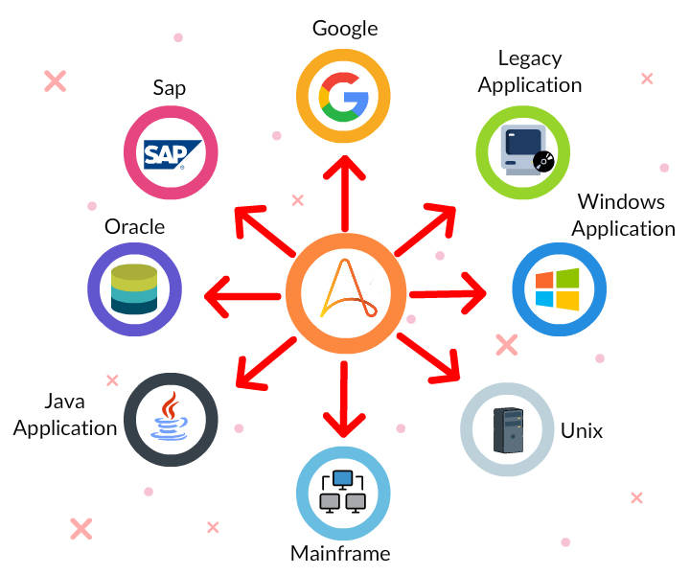

* Helps to **manage ERP front-end processes** such as SAP, Oracle Applications, and Peoplesoft.
* **Automates data transfers** (including import and export of data between applications or files).
* Enables execution and **management of windows control** as a background process (using object recorder).
* **Automates routine backups and file management** tasks.

Benefits of AA Enterprise

* Enables your teams to be 30-80% more efficient.
* Eliminates human error in data entry processes.
* Improves collaboration between employees and divisions.
* Increases transaction speeds.
* Reduces costs and achieves higher ROI.
* Integrates multiple, different systems and data.

Steps to Follow in AA Enterprise

The following sequence of events must be taken care of in Automation Anywhere Enterprise tool:

* **Create a bot** with developer license.
* **Upload bot/workflow and trigger** in control room.
* **Check the status of the files** uploaded to control room. Changes on a previously uploaded file are indicated with the caption [old, same, new]).
* **Execute the bot** in runner client from a control room.
* **Verify/monitor** the bot execution from a control room.

Know the Terms

* ***Task/Bot*** is a set of instructions.
* ***Trigger*** are activities scheduled based on some condition, such as execution of a bot when a folder or file is updated.
* ***Workflows*** are flow diagrams where bots are executed in a sequence.

AA Enterprise - Architecture

AA Enterprise comes with a simple architecture that comprises:

* **Control Room**: To access and manage automation tasks from anywhere anytime. All automated scripts/tasks are uploaded to control room. Control room can schedule the execution of the task in remote machine/bots.
* **Client**: Used for developing a bot, designing a workflow and for creating triggers.

Control Room

A control room is an interface where the overall process automation status is monitored.

**Key Tasks**:

* Creating users and Assigning user access.
* Accessing and managing tasks.
* Identifying the number of bots required for a task.
* Monitoring task progress and status.
* Scheduling execution of tasks/bots.
* Facilitating upload and download of Metabots.
* Work with general settings (such as configuring email server and version control).

***Ideally, it is one control room per customer.***

Control Room

A control room is an interface where the overall process automation status is monitored.

**Key Tasks**:

* Creating users and Assigning user access.
* Accessing and managing tasks.
* Identifying the number of bots required for a task.
* Monitoring task progress and status.
* Scheduling execution of tasks/bots.
* Facilitating upload and download of Metabots.
* Work with general settings (such as configuring email server and version control).

***Ideally, it is one control room per customer.***

##### Control Room - Features

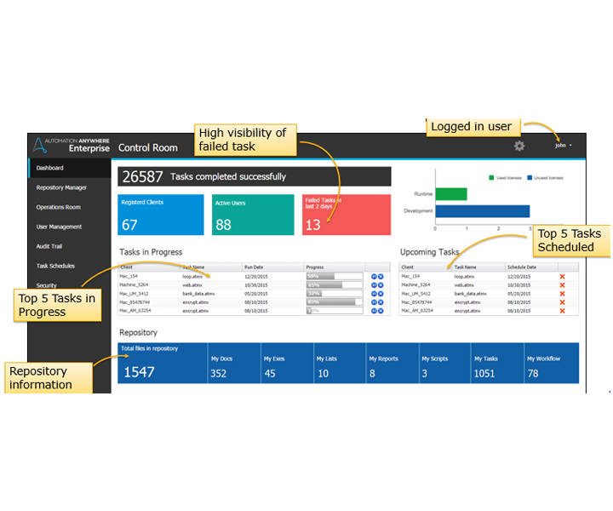

**Dashboard**: View a task's relevant activities.

**Repository Manager**: Manage automation files repository (Schedule, Deploy and Run tasks).

**Operation Room**: View the control room history and tasks in progress.

**User Management**: Configure users (Clients and Administrators), maintain or delete permissions, define roles.

.

##### Control Room - Features

**Audit Trail**: Displays recent activities of users and administrators.

**Task Schedules**: View schedule details.

**Security**: Manage user roles.

**Clients**: Manage Clients.

**Credential Manager**: Securely manage (create/update/store) sensitive details in the form of credentials to be used for automation tasks.

##### Client

A client is differentiated based on the license provided -

**Development Client**: Machines with development license is used to create the tasks (bots)/workflow and upload the same to control room.

**Runtime Client**: Machines with runtime license is used to trigger the tasks.

The upcoming cards will explain how the client differentiation is implemented.

User Management

In control room, **users are assigned with roles to determine the activities they can perform**.

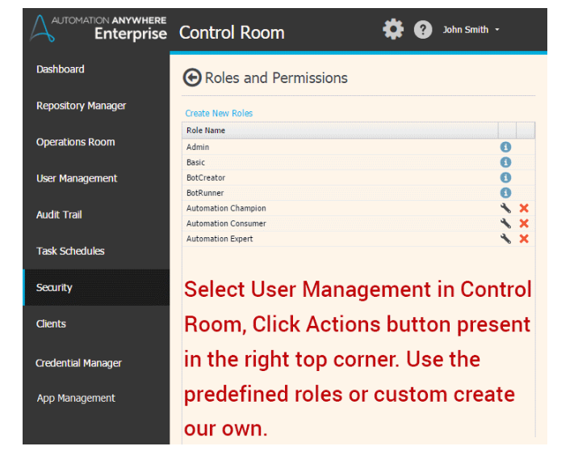

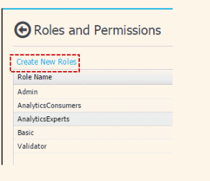

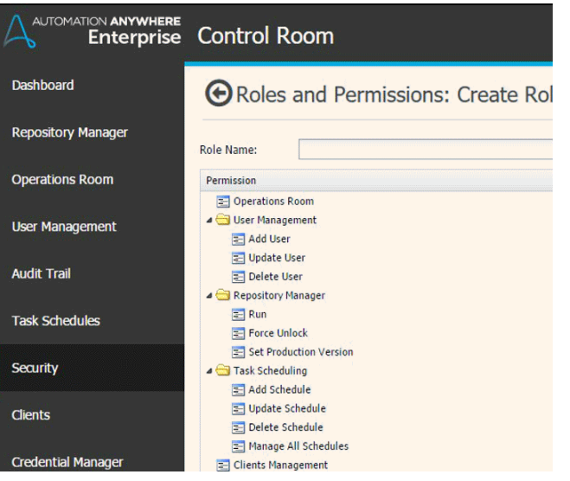

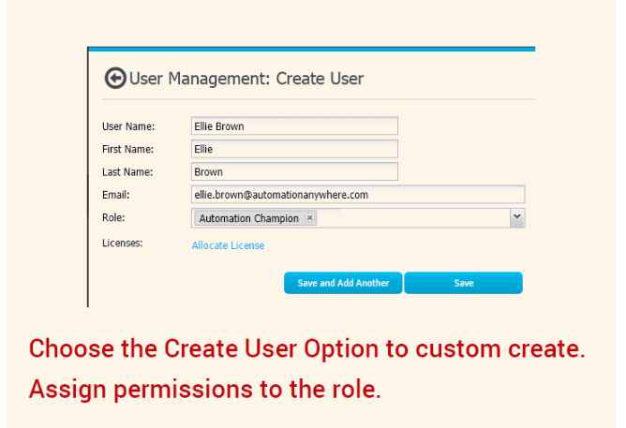

* Use 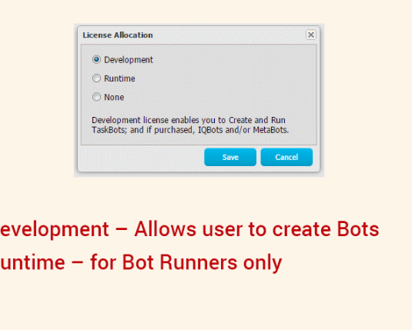the predefined roles, such as Admin, and Basic. Or, create your custom roles.
* Assign permissions to the roles such as provide rights for scheduling tasks, allowing upload/download.

User Management

Once you decide on the roles and define them:

* You can create users.
* Assign them roles.
* Allocate licenses to them. - Bot Creator role requires a development license. - Bot Runner role requires a runtime license.

##### What is a Bot?

An internet Bot, aka, web robot, or simply known as a bot is **a software application that runs automated scripts** over the internet. In general, a bot executes easy and structurally repetitive tasks, at a much larger rate than a human.

In this topic, you will get to know about Task Bot, Meta Bot, and IQ Bot.

##### Task Bot

**Task Bot**: Task bot is a bot that performs repetitive, rule-based tasks that rely on structured data. It is ideal for front-end automation.

If you have trouble playing this video. Please download the root certificate and proxy certificate and install.

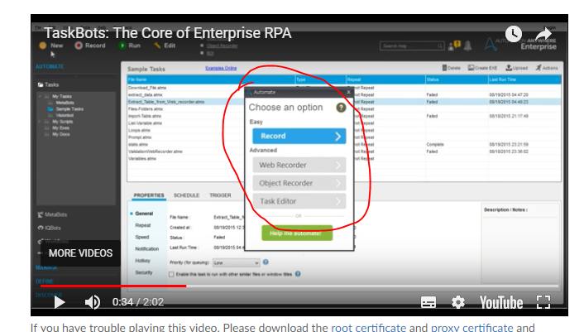

It works on presentation layer.

##### Meta Bot

**Meta Bot**: Meta bot is a bot that performs complex, multi-system dependent processes (helps to retrieve data from multiple systems, Extended RPA). It facilitates scalability.

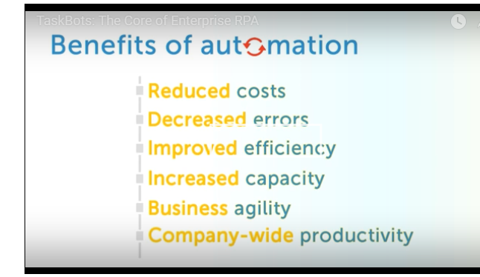

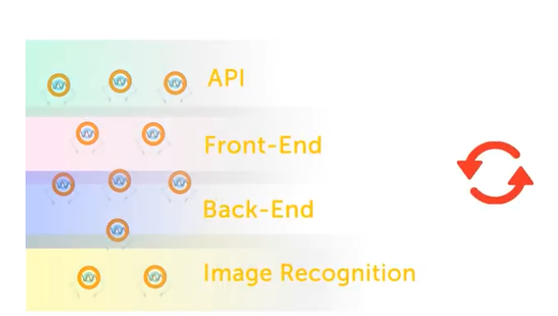

IQ Bot

* Cognitive in nature as they learn from human behavior using machine learning technologies.
* Can be trained to capture, enrich and validate semi-structured data intelligently.
* Engages with the human to find out areas which can become the next biggest productivity lever.
* Takes feedback from human engagement to establish improvements.
* Accumulated learning enables IQ bots to scale accuracy improvement and work much faster thereby reducing processing costs.

In short, ***IQ Bots create hyper-productive workforce***.

##### Inside an IQ Bot

#### **An IQ bot logic comprises:**

**Unsupervised Learning**:

* Proprietary algorithms to classify data based on multiple layers of methods.
* Review the data and recognize patterns through in-process analysis.
* Integrated with RPA to fetch meaningful actions during the automation process.

Inside an IQ Bot

**Supervised Learning**:

* Automatic recommendation of next course of action through pattern recognition.
* Enables speed and accuracy through pre-defined confidence thresholds.

**Cognitive Engine**:

* Detects document noise through proprietary algorithms.
* Extracts correct and accurate information from the data streams through templates.
* Allows reuse of semantic models across multiple use-cases.

##### IQ Bot

**IQ Bot**: Manages through fuzzy rules using unstructured data. Enables application of learning to process.

Create a Bot Using AA Enterprise

To create a basic bot using AA Enterprise tool, you need to know about:

* The **logic** to create the bot
* **Variables** (system and custom)
* **If/Else logic**
* **Loop command**

AA Enterprise comes with more than 237+ commands. You can create bots using these commands by establishing a logical flow.

Variables

There are two types of variables:

* **System variable**
  + Predefined list
  + Contains data required for day to day process (excel column, rows, extracting date)
  + Enables performing loop operation.
* **User defined**/**custom** variables: These variables can be further categorized into two types.
  + variables with values
  + variables without values (null variables)

##### Tasks Explained

In the next set of cards, you will be going through a sequence of videos explaining few basic tasks that can be automated using AA Enterprise tool.

These are the simplest form of task bots that can be created.

##### System Variables

This video will talk about one of the frequently used system variable **Array**.

##### Custom Variables

This video explains the creation of a custom counter variable.

##### Database Write

This video explains how to connect to a database, usage of a loop statement, and introduces you to the prompt command.

##### Email Automation

This video will give you an explanation on how to connect to the mailbox and read the emails.

##### Excel Integration

This video explains how to interact with Excel.

##### PDF Integration

The video explains the various PDF integration capabilities.

##### String Operation

The video helps you learn about string operation commands.

##### FTP

This video will help you learn about integrating FTP.

##### Manage Windows Control

The video will explain you about managing Windows control comma

##### Terminal Emulator

The video will explain how the software works with Linux, Unix, or Mainframe.

##### Encrypt and Decrypt

This video details on how to perform encryption and decryption.

##### Into the World of Recorders

**Recorder**: **A quick, intuitive, and secure way of creating automation.**

#### **Features**

* Recorded automation can be easily modified to address unique business needs or exception scenarios
  + Avoids re-recording of the entire process.
* Minimizes training requirements.
* The basic structure of the process is created faster enabling more time for testing.

##### Attended Automation

**Attended automation**: Working with humans

After you have finished recording a process, use a message or prompt dialog to insert logic into the already created bot to interact with humans.

Thus bots can modify the course of a process based on human input in the middle enabling decision making. (Hope you remember watching prompt usage in the previous topic).

**Decision-making can also be incorporated by using standard constructs such as “if-then-else”.**

Screen Recorder

* A screen recorder **captures mouse events - movements, clicks, click and drag**.
* A screen recorder **captures keystrokes like Insert keystrokes**.
* It is limited to static screens, simple desktop/web applications.
* It is faster than creating a task manually.

##### How Screen Recording Works?

This video demonstrates screen recording.

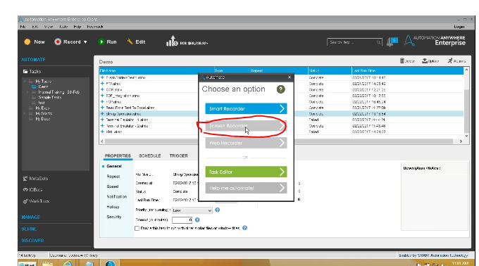

Press Windows+r button – to open run window.

Smart Recorder

* A **Smart Recorder** is ideal for **desktop applications** and **websites**.
* It records based on a provided window title.
* It captures windows objects and controls such as - Text from drop-down menus - List boxes - Buttons - Mouse click actions - Status from radio buttons and check boxes.

##### How It Works?

This video demonstrates about the smart recorder.

Web Recorder

* A **web recorder** is ideal for **websites**.
* It records based on a provided URL.
* A web recorder extracts data.
* It navigates through web controls.
* It is strictly a **browser-based tool**.

Web Recorder

**Commands performed:**

* Open and close websites in browser sessions.
* Manage web controls.
* Download data.
* Extract additional data from the web.
* Test websites and locate broken links.
* Navigate URLs.
* Extract website source code.
* Search by captions.
* Navigate back.
* Execute a Java-based script.

##### Web Recorder

It enables the extraction of:

* **Regular (structured) data**
* **Table data**
* **Pattern-based data**

##### Extract Structured Data

The video explains how to capture values using the web recorder.

##### Extract Table

This video demonstrates how you can capture a table out of a web page using the web recorder.

##### Extract Pattern

The video explains how to extract a pattern using the web recorder

##### Workflow Designer

**Workflow** is a high-level graphical view of your business process like conditional logic, tasks initiation, etc. A workflow can be easily created by using the intuitive drag and drop interface.

##### How Workflow Works?

This video demonstrates the Workflow Designer.

##### Report Designer

**Report Designer** generates graphical reports that display the status of tasks, workflows. It also calculates and shows a graphical view of ROI over time.

#### **Report Types**

* Task Run, Task Timeline, Workflow Run, Workflow Timeline, ROI, and Visual Logs.

##### How Report Designer Works?

The video demonstrates the report designer.

MetaBot

***Are you looking at optimizing and standardizing your application processes?***

**Metabot is your solution**.

Metabot assists you to:

* Create automation building blocks by capturing information in the form of visuals or application APIs.
* Integrate the building blocks as commands that can be used by different processes.

Create a MetaBot

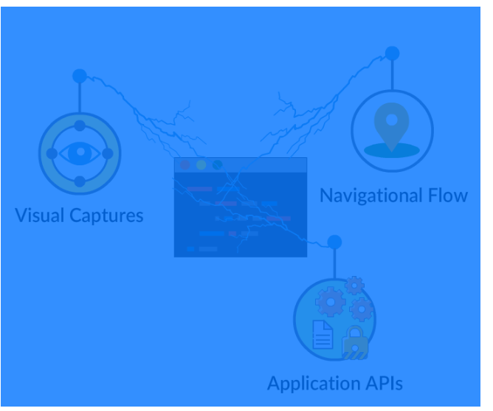

MetaBot can be created through:

* Visual captures - GUI components of an application. - Referred to as Screen in MetaBot Designer.
* Application APIs
  + Interfaces that perform low-level operations of an application.
  + Referred to as DLL in MetaBot Designer.
* Navigational flows
  + Logic created using visual captures and APIs.

***MetaBot designer must be installed in addition to the Automation Anywhere Enterprise for working with MetaBots.***

##### MetaBot Designer

The MetaBot Designer helps you to:

* Create MetaBots.
* Add Assets – Screens, and DLLs to your MetaBots.
* Manage your MetaBot Assets.
* Configure and calibrate the screens.
* Create custom objects on the screens.

##### MetaBot Designer

* Create Logic to represent a navigational flow using Screens and DLLs.
* Upload the MetaBots to the Control Room for use by other Enterprise Client users.
* Edit MetaBots created by other users.
* Export and Import MetaBots for use in different Control Room setups.

Benefits

MetaBot provides a wide range of benefits:

* Listed in the automation command library in AA Enterprise
  + Enables reuse, by any automation task.
* Org-wide automation standardized rapidly by leveraging MetaBot library.
* Ensures systematic, accelerated automation ROI.
* Eliminates common navigational errors in complex automation tasks.
* Automates without requiring access to live application.
* Allows easy calibration to newer versions of applications and ensures compatibility.

##### Creating a Metabot

Here is a short video that will explain how a MetaBot is created.

##### Cognitive RPA - On the Rise!

Here is an introduction to Cognitive RPA.